Task 4: Setup and Use a Firewall on Windows/Linux

Objective
To configure, test, and document basic firewall rules that allow or block network traffic using UFW on Kali Linux. This task demonstrates understanding of firewall management and traffic filtering.

Environment
- Operating System: Kali GNU/Linux 2025.4
- Firewall Tool: UFW (Uncomplicated Firewall)
- User: thorappan(Adith Joel Suresh)

Step 1: Open Firewall Configuration Tool
On Linux, the firewall is managed via the terminal using UFW.
Command used:
sudo ufw enable
This command enables the UFW firewall service.
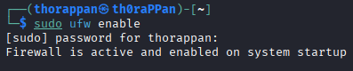

Step 2: List Current Firewall Rules
To check the current status and existing rules:
sudo ufw status
Output showed:
Status: active
This indicates that the firewall is active but no custom rules were configured initially.
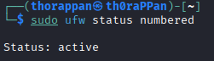

Step 3: Block Inbound Traffic on Port 23 (Telnet)
A rule was added to block inbound Telnet traffic, which is considered insecure.
Command used:
sudo ufw deny 23/tcp
Verification:
sudo ufw status numbered
This displayed a DENY rule for port 23 (IPv4 and IPv6).
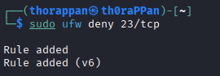

Step 4: Test the Block Rule
The blocked port was tested locally using Netcat.
Command used:
nc -zv localhost 23
Expected result:
Connection refused
This confirms that the firewall is actively blocking traffic on port 23.
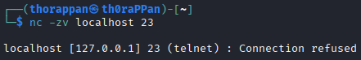

Step 5: Allow SSH Traffic (Port 22)
To ensure secure remote access, SSH traffic was explicitly allowed.
Command used:
sudo ufw allow 22/tcp
Verification:
sudo ufw status numbered
This showed ALLOW rules for port 22 alongside the Telnet block rule.
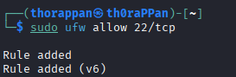

Step 6: Remove the Test Block Rule
After testing, the Telnet block rule was removed to restore the system to its original state.
Commands used:
sudo ufw delete 1
sudo ufw delete 1
(Used twice to remove IPv4 and IPv6 rules)
Final verification:
sudo ufw status numbered
Only the SSH allow rule remained.

Step 7: Documentation of Commands Used
- sudo ufw enable
- sudo ufw status numbered
- sudo ufw deny 23/tcp
- nc -zv localhost 23
- sudo ufw allow 22/tcp
- sudo ufw delete <rule_number>
Screenshots of each step are included in the GitHub repository as evidence.

Firewall Traffic Filtering Summary
A firewall acts as a security control that monitors and filters network traffic based on predefined rules. UFW filters traffic using criteria such as port number and protocol. In this task, inbound Telnet traffic on port 23 was blocked to reduce security risks, while SSH traffic on port 22 was allowed to enable secure remote access. This demonstrates how firewalls help protect systems by limiting unnecessary or insecure network connections.

Part B: Windows Firewall Configuration

Environment
- Operating System: Windows 10 / Windows 11
- Firewall Tool: Windows Defender Firewall with Advanced Security

Step 1: Open Firewall Configuration Tool
- Press Win + R
- Type wf.msc and press Enter
- Windows Defender Firewall with Advanced Security opens

Step 2: List Current Firewall Rules
- Click Inbound Rules from the left panel
- Review the list of existing inbound firewall rules
This shows all currently configured rules controlling incoming network traffic.
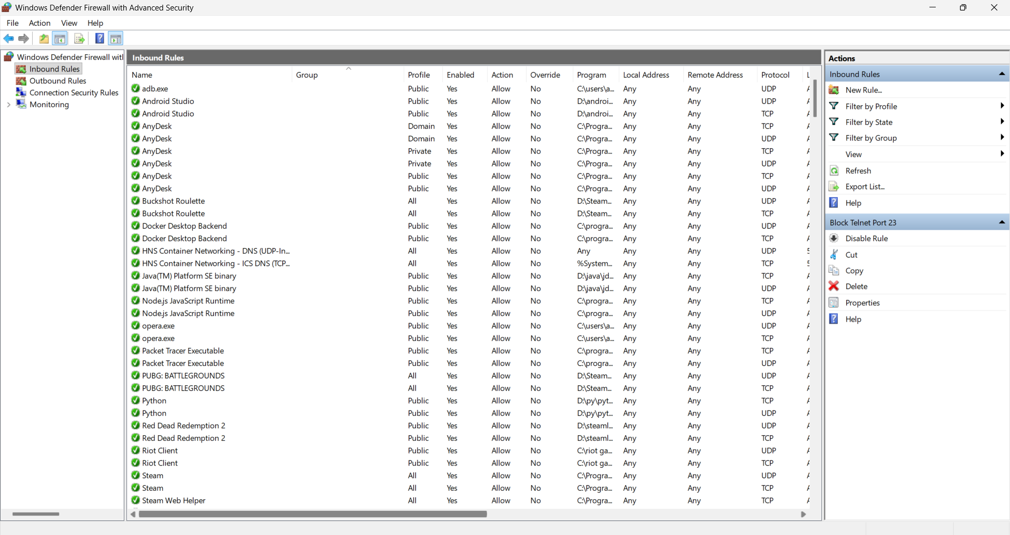

Step 3: Block Inbound Traffic on Port 23 (Telnet)
- Click New Rule…
- Select Port → Next
- Choose TCP
- Select Specific local ports and enter 23
- Click Next
- Select Block the connection
- Apply the rule to Domain, Private, and Public
- Name the rule: Block Telnet Port 23
- Click Finish
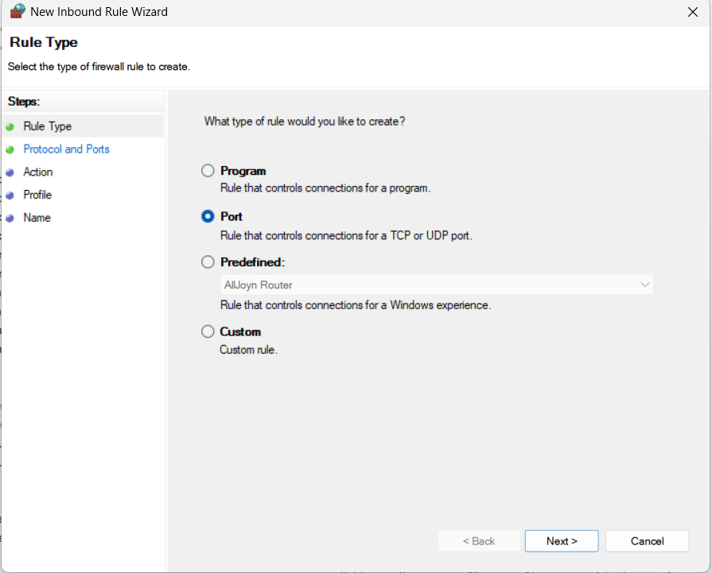
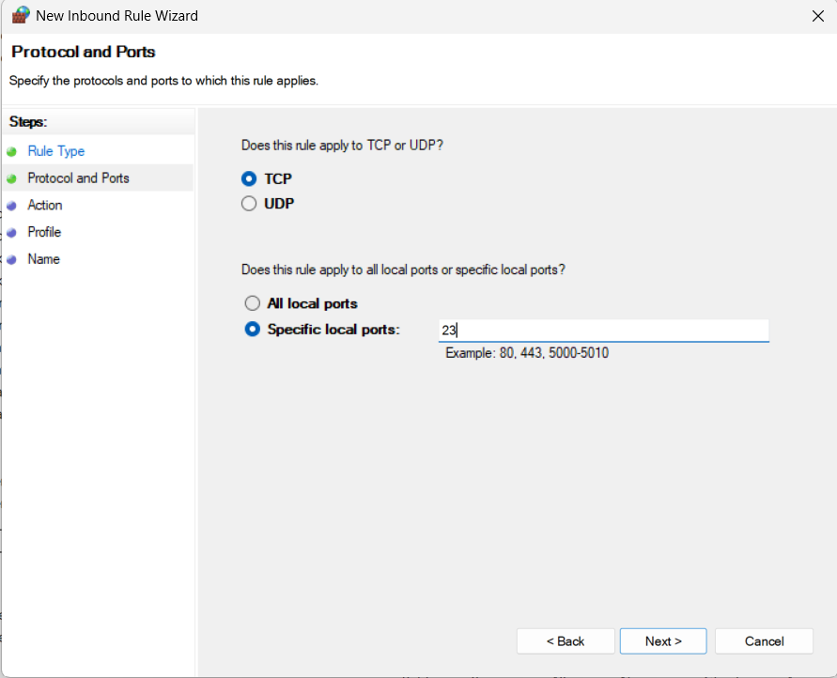
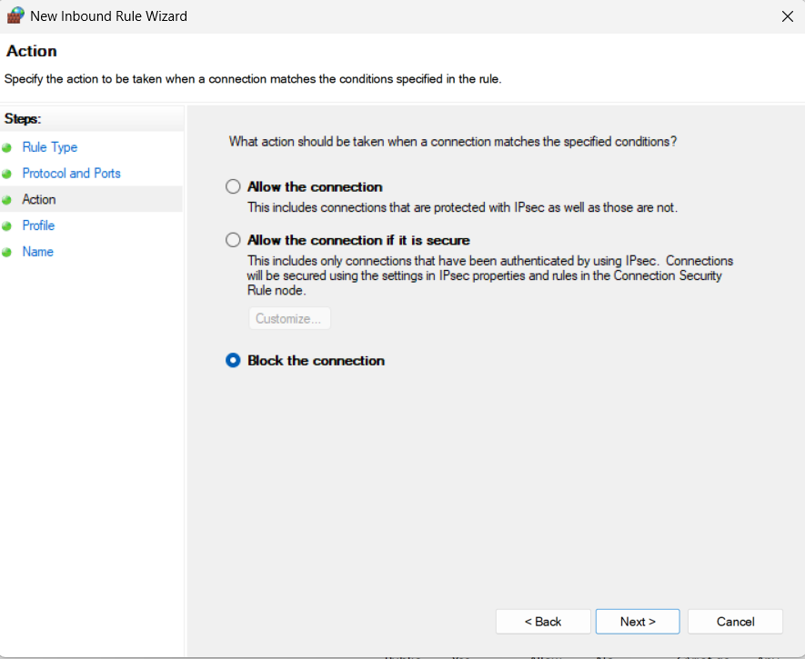

Step 4: Test the Block Rule
Since Telnet is disabled by default on Windows, PowerShell was used to test the port.
- Open PowerShell as Administrator
- Run:
Test-NetConnection -ComputerName localhost -Port 23
This confirms that inbound traffic on port 23 is blocked by the firewall.
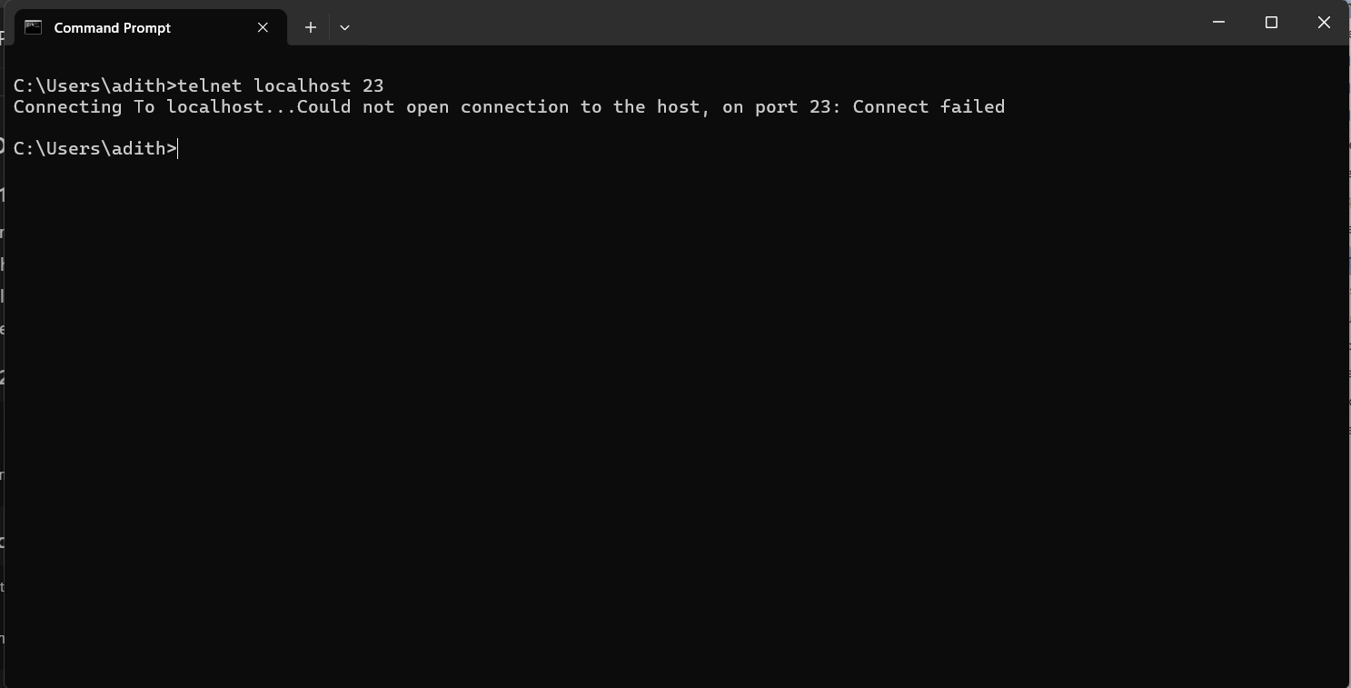

Step 6: Remove the Test Block Rule
- Go to Inbound Rules
- Locate Block Telnet Port 23
- Right-click the rule
- Select Delete
This restores the firewall to its original state.

Firewall Traffic Filtering Summary (Windows)
Windows Defender Firewall filters network traffic by evaluating inbound and outbound packets against configured rules. Each rule specifies conditions such as port number, protocol, and network profile. Traffic matching a block rule is denied, while allowed traffic is permitted. Blocking Telnet improves system security, while allowing SSH enables secure remote management.

